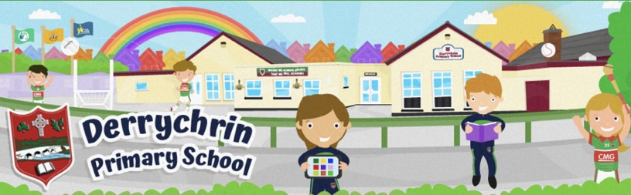
Parent Survey 2021
Home Learning - Parent Survey

Thank you very much to parents and carers for completing the questionnaire and for your comments and responses about our school. We realise that this is a difficult time for everyone and appreciate you taking the time to respond to our survey. We had over 90 surveys completed which is a fantastic response, that is over 80% of the families within the school. We have compiled the results and are pleased to present them to you. Please read the document below.

The question regarding my child knows how to stay safe online revealed 8% of parents were concerned that their child didn’t know how to stay safe online. Looking at the survey we were able to see that the majority of these parents had children in Key Stage 1. During Term 3 we will be looking to focus on online safety for all pupils and organise a parent information session to help keep our children safe online when at home.

The results of this survey will be discussed and shared at the next governor’s meeting and with all our staff so that we can make our school an even better place for pupils, parents and staff. Parents’ suggestions are gratefully received and will be considered as we set our school development priorities for the future.

I would like to say thank you for your overwhelmingly supportive and positive responses. I am proud to report that 100% of parents/carers who replied stated that:

- Their child/children is/are well cared for in school.
- There was good communication between school & home during Lockdown.
- They knew how to contact the school or class teacher.
- That their child was happy to return to school.
- That their child feels safe at school.
- They are happy with the procedures and routines the school has put in place to ensure my child's safety and that of the whole Derrychrin PS community.

Response from each class:
Class | Teacher | Reply
P1 | Mrs Tohill | 80%
P2 | Miss Mc Vey | 80%
P3 | Miss Hughes | 84%
P4 | Mrs Hassan | 87%
P5 | Mrs Mc Guckin | 80%
P6 | Mrs Mc Kay | 70%
P7 | Mr O’Neill | 70%

Q1: There was good communication during lockdown and on the procedures for returning to school i.e. via text, twitter, Seesaw and sways.

Strongly Agree | 79%
Agree | 21%
Disagree | 0%
Strongly Disagree | 0%

Q2: I knew how to contact the school or class teacher if I had any concerns regarding educational or Safeguarding support.

Strongly Agree | 87%
Agree | 13%
Disagree | 0%
Strongly Disagree | 0%

Q3: My child was willing to engage in remote learning (online and paper) and could navigate Seesaw

Strongly Agree | 53%
Agree | 39%
Disagree | 8%
Strongly Disagree | 0%

Q4: My child knows how to stay safe online.

Strongly Agree | 29%
Agree | 62%
Disagree | 9%
Strongly Disagree | 0%

Q5: In the event of a future Lockdown would you prefer more ‘live’ lessons, pre-recorded lessons or a mixture of both types?

Live Lessons | 12%
Pre-recorded Lessons | 32%
Mixture of both | 56%

Q6: I found Seesaw a useful remote learning tool.

Strongly Agree | 51%
Agree | 46%
Disagree | 2%
Strongly Disagree | 1%

Q7: For home learning I prefer.

Mixture of online & paper | 83%
Online only | 2%
Paper Pack only | 15%

Q8: The home learning (Seesaw and paper copy) my child received was appropriate and manageable.

Strongly Agree | 61%
Agree | 38%
Disagree | 1%
Strongly Disagree | 0%

Q9: In supporting my child's home learning I found it.

Manageable | 40%
Manageable but challenging | 51%
Difficult to manage | 9%

Q10: Please select any devices your child used to engage in remote learning.

Desktop Computer | 4%
Laptop | 27%
Tablet | 50%
Mobile Phone | 19%

Q11: My child was happy returning to school.

Strongly Agree | 73%
Agree | 27%
Disagree | 0%
Strongly Disagree | 0%

Q12: My child feels safe in school.
Strongly Agree | 85%
Agree | 15%
Disagree | 0%
Strongly Disagree | 0%

Q13: I am confident that my child is well cared for in school.
Strongly Agree | 89%
Agree | 11%
Disagree | 0%
Strongly Disagree | 0%

Q14: I am happy with the procedures and routines the school has put in place to ensure my child's safety and that of the whole Derrychrin PS community.
Strongly Agree | 90%
Agree | 10%
Disagree | 0%
Strongly Disagree | 0%

We strive to work as closely with every family connected to our school as much as possible, as we believe that working together is the best way to ensure your child reaches their full potential. We would like to say a VERY BIG THANK YOU for your many positive and supportive comments in describing the school and all its staff.

Below is a Word Cloud of the most commonly used words used in the feedback to staff.

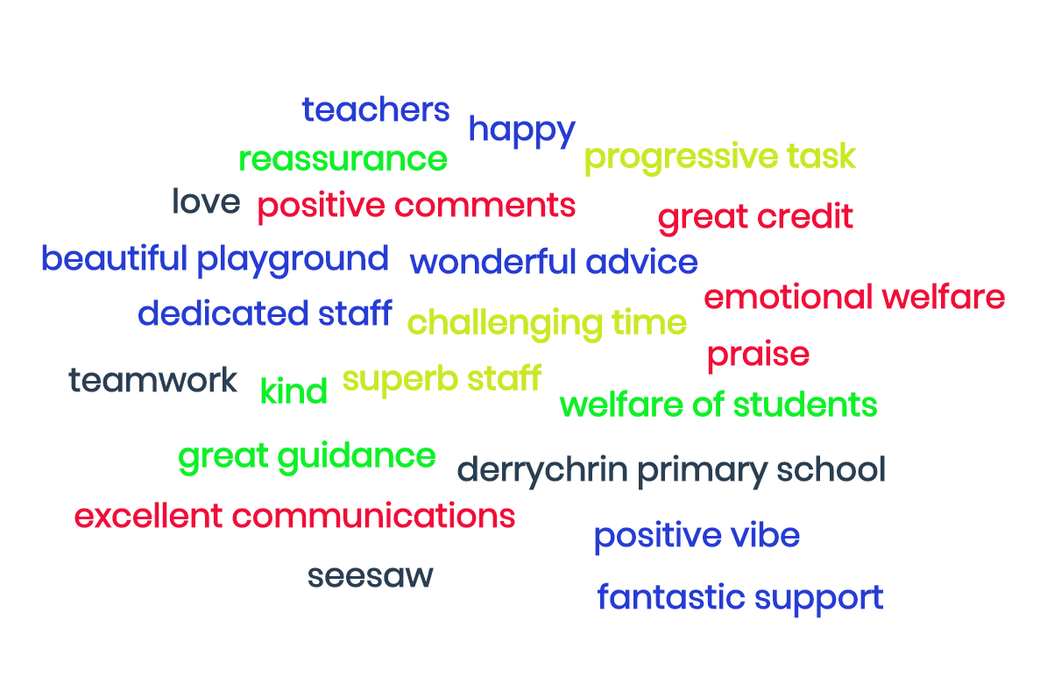

Parent Survey 2021

